ProjectDesignPhase-II

DataFlowDiagram &User Stories

|  |  |
| --- | --- |
| Date | 17-October-2023 |
| TeamID | 90EDCD5A653F97E965540D7A2F454585 |
| ProjectName | Quantitative Analysis Of Candidates In 2019 Lok Sabha Elections |
| MaximumMarks | 4 Marks |

# Data Flow Diagrams:

A Data Flow Diagram (DFD) is a traditional visual representation of the information flows within a system. A neat and clear DFD can depict the rightamount of the system requirement graphically. It shows how data enters and leaves the system, what changes the information, and where data isstored.

# Example:[(Simplified)](https://developer.ibm.com/patterns/visualize-unstructured-text/)

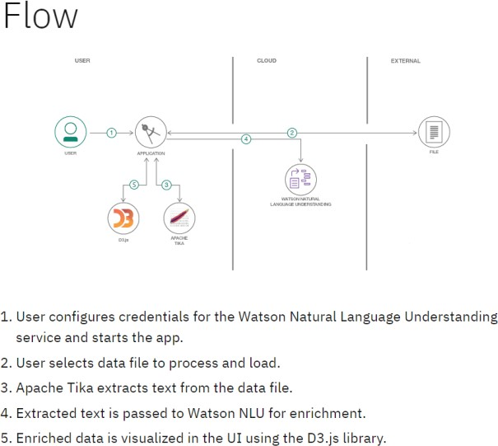

DATA FLOW DIAGRAM

PUBLIC USER

**User Stories**

Use the below template to list all the user stories for the product.

|  |  |  |  |  |  |  |
| --- | --- | --- | --- | --- | --- | --- |
| **UserType** | **Functional**  **Requirement (Epic)** | **UserStoryNumber** | **UserStory/Task** | **Acceptance criteria** | **Priority** | **Release** |
| Data Analyst | Perform Quantitative Analysis of Candidates in the 2019 Lok Sabha Elections | US001 | As a data analyst, I want to collect and clean the raw election data for the 2019 Lok Sabha Elections to prepare it for quantitative analysis. | Validate and clean the data, addressing any missing or erroneous entries. | High | Release 1.0 |
| Researcher | To research the Quantitative Analysis of Candidates in the 2019 Lok Sabha Elections | US002 | As a researcher, I want to access and analyze the quantitative data of candidates in the 2019 Lok Sabha Elections to understand voting patterns and demographics.. | Researchers should be able to select a specific region or constituency to analyze data | Medium | Release 2.0 |
| Election Commission Officer | Access to Election Data for Quality Assurance | US003 | As an Election Commission Officer, I want to access and validate the election data used for quantitative analysis to ensure its accuracy and compliance with official records. | Generate reports highlighting any discrepancies or inconsistencies between the analyzed data and official records. | High | Release 1.0 |
| System Administrator | System Administration for Quantitative Analysis of Candidates in the 2019 Lok Sabha Elections | US004 | As a system administrator, I want to ensure the reliability and availability of the data analysis system for the 2019 Lok Sabha Elections, including performing routine maintenance and addressing system issues. | Monitor system health and performance to detect and address potential issues. | High | Release 1.0 |